SRS
(Software Requirement Specification)

For

LMS (Learning Management System)

Prepared By:

Tanvi Gupta

Date :1 August 2026

Project: Learning Management System (LMS)

Table of Contents

1. INTRODUCTION..

1.1 Purpose. …………………………………………………………………………………………………… 1

1.2 Scope………………………………………………………………………………………………………..1

1.3 Intended Audience………………………………………………………………………………………….1

2. Overall Description..

2.1 User Interface……………………………………………………………………………………………….2

2.2 Technical Specification……………………………………………………………………………………..2

3. Functional Requirements

4. Non-Functional Requirements..
4.1 Performance…………………………………………………………………………………………
4.2 Security…………………………………………………………………………………………………
4.3 Software Quality……………………………………………………………………………………….

5. System Features..
5.1 System Architecture 5.2 System Workflow
5.3 Use Cases

- Introduction

1.1 Purpose
The purpose of this Software Requirements Specification (SRS) is to define the requirements for the proposed Learning Management System (LMS). This document serves as a reference for understanding the project's objectives, business requirements, functional and non-functional requirements, system architecture, and overall workflow before the development phase begins.
The LMS is intended to provide a centralized platform that enables students to learn, practice, track their academic progress, and receive personalized recommendations, while allowing instructors and administrators to efficiently manage courses, study materials, assessments, and student performance.
This document is prepared after analyzing the project requirements and discussions regarding the expected features and workflow of the system.

1.2 Scope
The proposed Learning Management System is a web-based platform designed to simplify and improve the learning process for educational institutions, coaching centers, and online training organizations.
The system will support three primary user roles:
- Student
- Teacher
- Admin
The platform will allow students to access learning resources, practice previous year questions, attempt quizzes, submit assignments, monitor their progress, and receive AI-generated study recommendations based on their performance.
Teachers will be able to create courses, upload study material, conduct assessments and monitor student progress. Admins will manage users, courses, reports, and overall system activities.

1.3 Intended Audience
This document is intended for:
- Project Mentor
- Development Team
- UI/UX Designers
- Testing Team
- Project Stakeholders
- Client
It provides a clear understanding of the system requirements before implementation begins.

2. Overview
2.1 User Interface
The Learning Management System (LMS) will provide a responsive and user-friendly web interface that is accessible on desktops, tablets, and mobile devices. The system will offer separate dashboards for Students, Teachers, and Admin , each displaying features relevant to their roles.
The interface will include:
- Secure Login and Registration
- Dashboard
- Course Management
- Assignments and Quizzes
- Progress Reports
- AI Learning Assistant
- User Profile
- Admin Panel

2.2 Technical Specification
The Learning Management System (LMS) will follow a three-tier architecture consisting of the Frontend Layer, Backend Layer, and Database Layer.

Component | Technology
Frontend | React.js
Backend | Python/Java (Spring Boot)
Database | PostgreSQL
Authentication | JWT
API Testing | Postman
Version Control | Git & GitHub

3. Functional Requirements
The LMS shall provide the following functionalities to meet the requirements gathered from the client. The most important requirement is what the client expects.
So according to the client we can make this 1) lms available to 100 users.
- Secure registration and login.
- Separate dashboards for Students, Teachers, and Admin.
- Role-based access control.
- Profile management.
Students Requirement:
- Study/Lib resources: Books , Notes, Extra Study Materials
- PYQ/ANS available at single place
- Test(On a regular basis for practice)
- Reports after every week to help analyze performance

User Management
- User Registration and Login
- Secure Authentication using JWT
- Role-Based Access (Admin, Teacher, Student)
- Profile Management
- Password Reset
Course Management
1. Create/update Course
2. Upload videos for course content
3. Search courses through search option
Lesson Management
1. Download Study Materials
2. View Previous Year Question Papers
Performance Analytics
1. Weekly Progress Reports
2. Quiz and Assignment Performance
3. Graphical Performance Dashboard
4. Learning History Tracking
Discussion Forum
1. A section where students can discuss with their friends, ask queries to teachers and more..
AI-Based Learning Features
1, AI Learning Assistant for Doubt Solving
2. AI Study Material Recommendations
3. AI Performance Analysis
Admin Module:
1. User Management
2. Course Management
3. Report Generation
4.Performance Monitoring
Payment Module:
1. Online Payment for Premium Courses
2. Payment History

4. Non-Functional Requirement
Non-functional requirements define the quality attributes of the system and ensure that the LMS performs efficiently, securely, and reliably.
4.1 Performance
The LMS should provide fast and reliable performance under normal conditions.
- The system should support multiple concurrent users.
- Average page response time should be within 2–3 seconds.
- Reports and dashboards should load efficiently.
- The application should maintain consistent performance during assessment

4.2 Security
Security is essential to protect user information and learning data.
- JWT-based user authentication.
- Role-based access control for Students, Teachers, and Admin.
- Passwords should be securely encrypted.
- Data transmission should occur over HTTPS.

4.3 Software Quality
The LMS should be developed following software quality standards to ensure maintainability and usability.
- User-friendly and responsive interface.
- Modular and maintainable code structure.
- Easy integration of future features.
- High availability and reliability.
- Regular backup and recovery support.

5. System Features
5.1 System Architecture

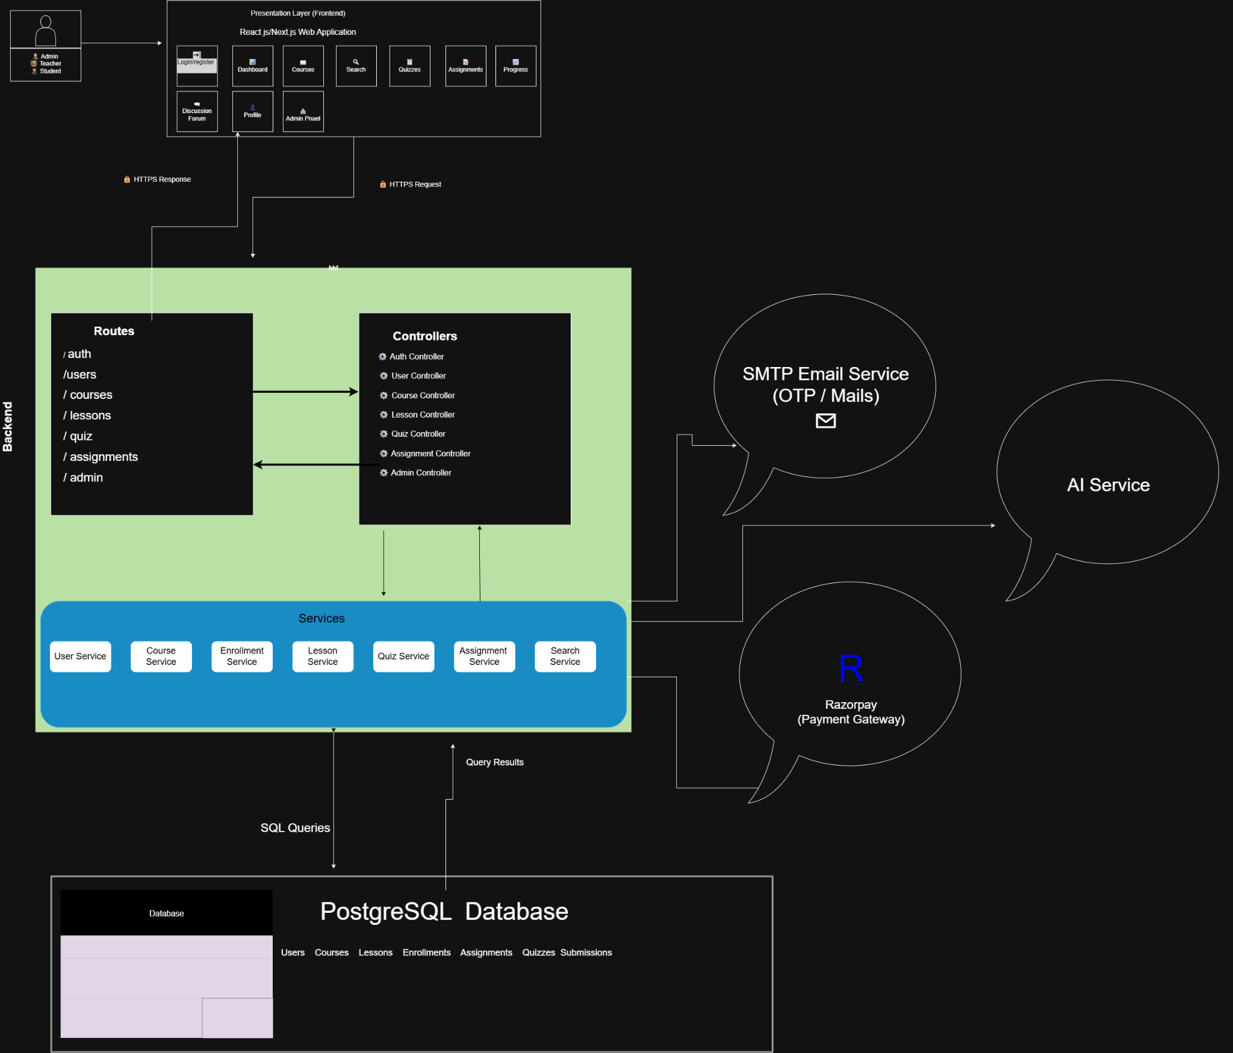
5.2 System Workflow
User Registration/Login
│
▼
Authentication
│
▼
Role-based Dashboard
(Student / Instructor / Admin)
│
▼
Instructor Creates Course
│
▼
Student Enrolls
│
▼
Learn → Quiz → Assignment
│
▼
Performance Analysis
│
▼
AI Recommendations & Reports
│
▼
Certificate Generation

5.3 Use Case
Student
- Register and log in.
- Browse and enroll in courses.
- Access study materials and video lectures.
- Practice previous year questions.
- Attempt quizzes and submit assignments.
- View AI recommendations and progress reports.
- Download course completion certificates.

Teacher
- Log in to the system.
- Create and manage courses.
- Upload videos, notes, and assignments.
- Create quizzes.
- Evaluate student submissions.
- Monitor student progress.

Admin
- Manage users and instructors.
- Approve or manage courses.
- Monitor overall system performance.
- Generate reports and analytics.
- Manage notifications and system settings.

Conclusion
The proposed Learning Management System is designed to provide a centralized and intelligent platform for online education. It combines course management, assessments, AI-assisted learning, and performance analytics to improve the overall learning experience.

